Project Report Template

INTRODUCTION:-

* 1. Overview

Most functionality in modern vehicles, such as bus, is in one way or another controlled by computers. Mechanical systems are increasingly replaced by software residing in the vehicle management system. As these management systems grow larger and larger, they become increasingly more complex to develop and maintain.Hand in hand with the increasing amount of control functionality demanded comes the increasing amount of information, or data, that these systems must manage and thereby the increasing complexity of the software required.DBMSs are used to structure data into databases, and can provide a powerful means of access to data in a controlled fashion. This thesis investigates how a DBMS could be introduced into vehicle management systems.

* 1. Purpose: -

Coordinate procurement of vehicles, and ensure their suitability for conditions and aim for standardisation of the fleet. Maintain a vehicle inventory for each type of vehicle.

2.Problem Definition and Design Thinking:-

2.1 Empathy Map

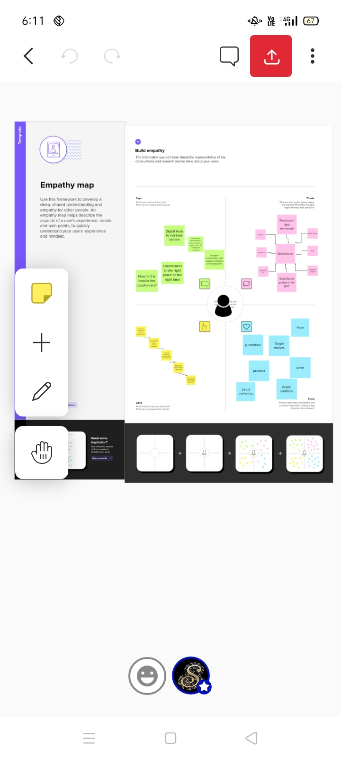

2.2 Ideation and Brainstorming map Screenshot







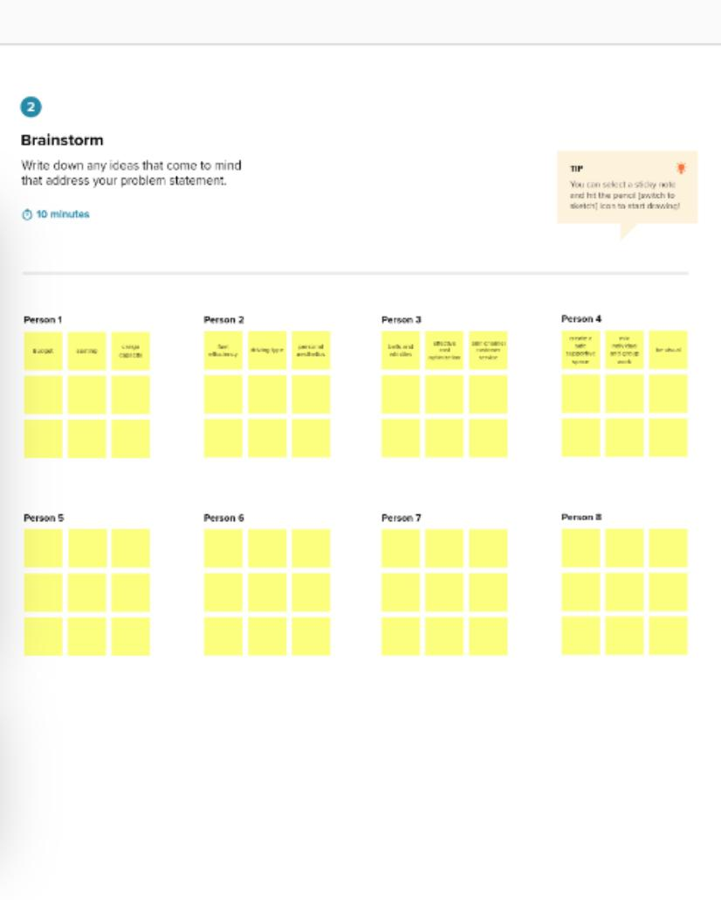



|  |  |  |
| --- | --- | --- |
| |  |  | | --- | --- | | |  | | --- | |  | | |

3.Reault:-

3.1 Data Model:

|  |  |
| --- | --- |
| Object name | Fields in the object |
| Object -1 | Field Label: Customer name  Data Type:Text |
| Object -2 | Field Label:Customer Mobile mo  Data Type:Number |
| Object -3 | Field Label:Vehicle Type  Data Type:Picklist |
|  |  |

3.2 Activity and Screenshot:-

Creating Developer Account

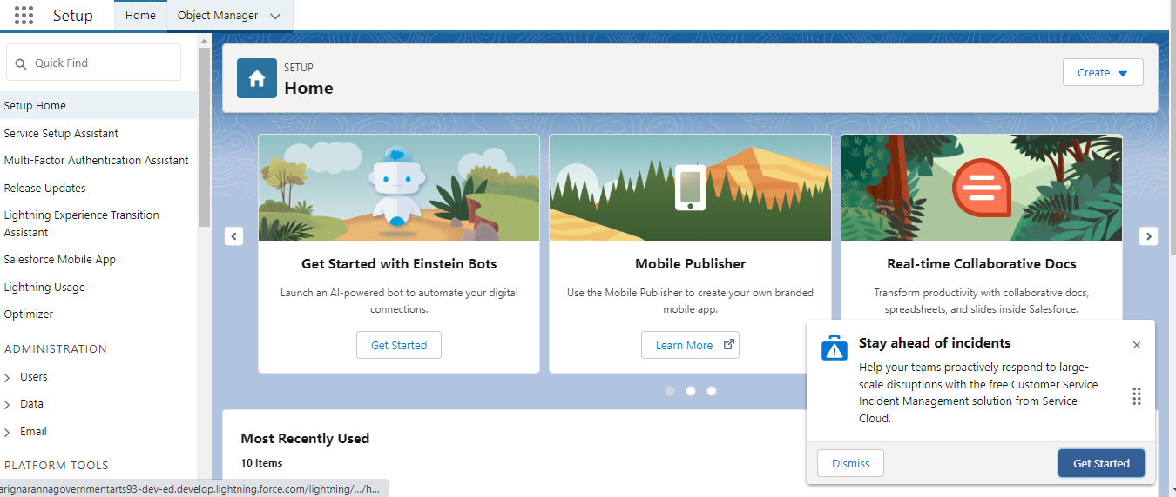

Object

To creation An Object

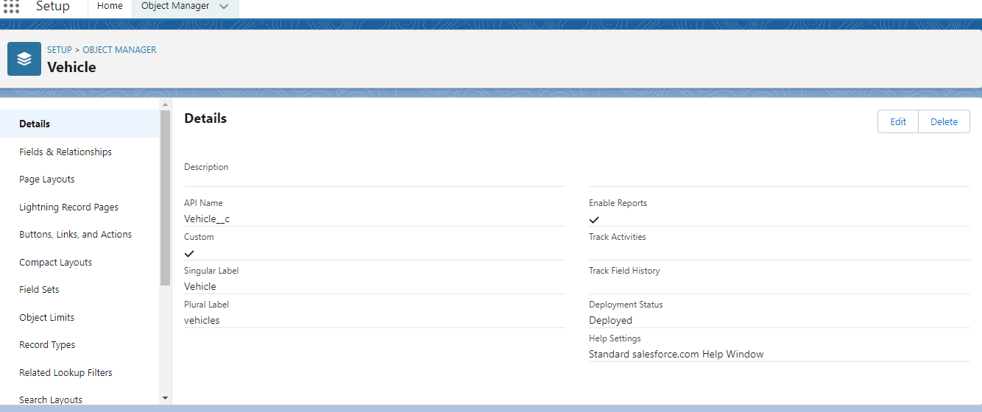

Create a Driver Object

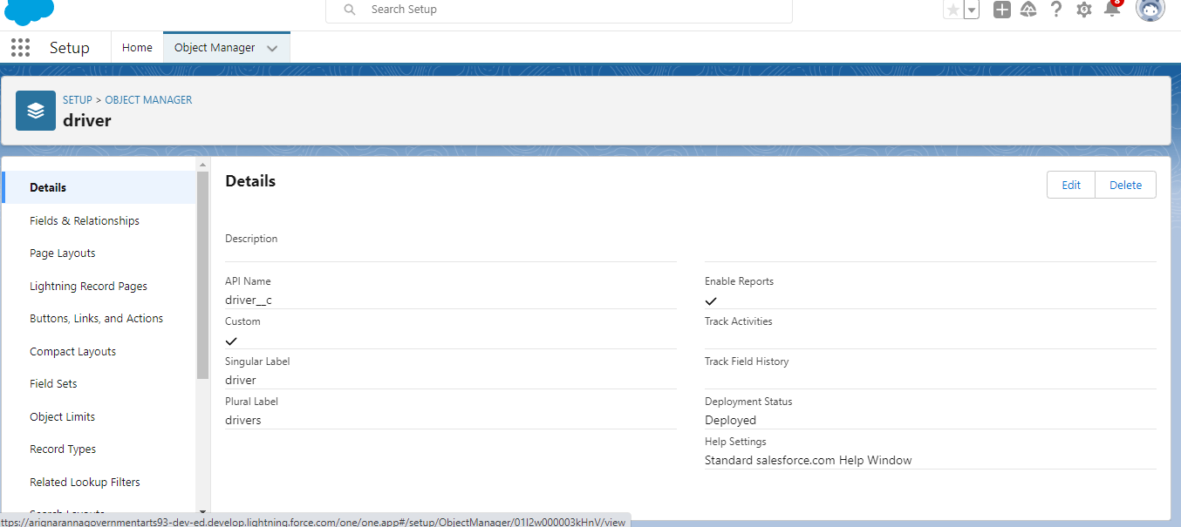

Creation Of Fields

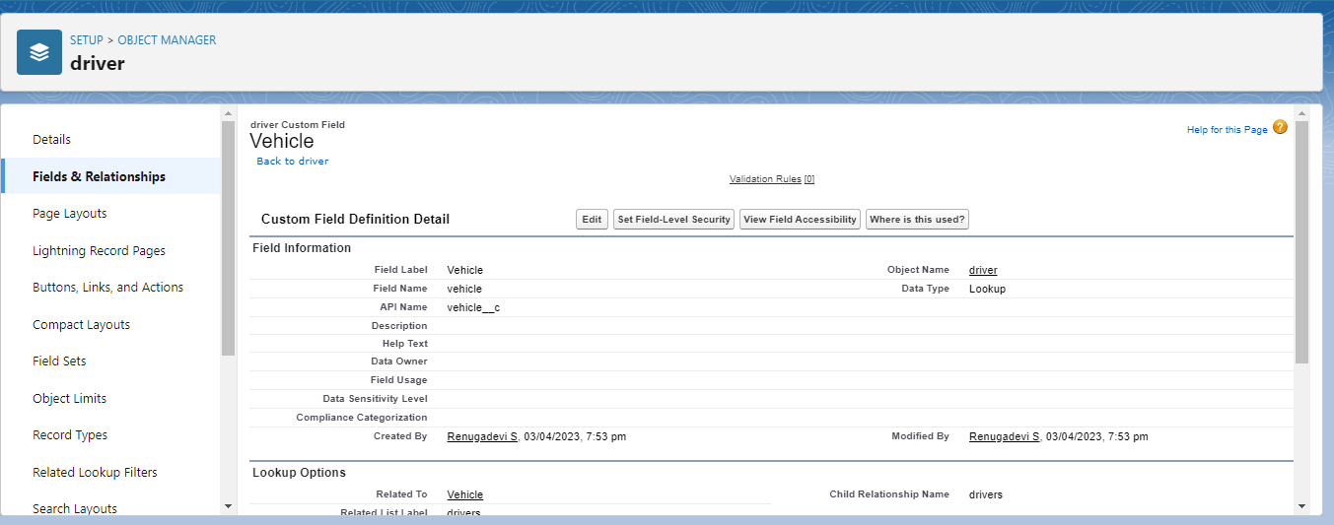

Fields in driver object

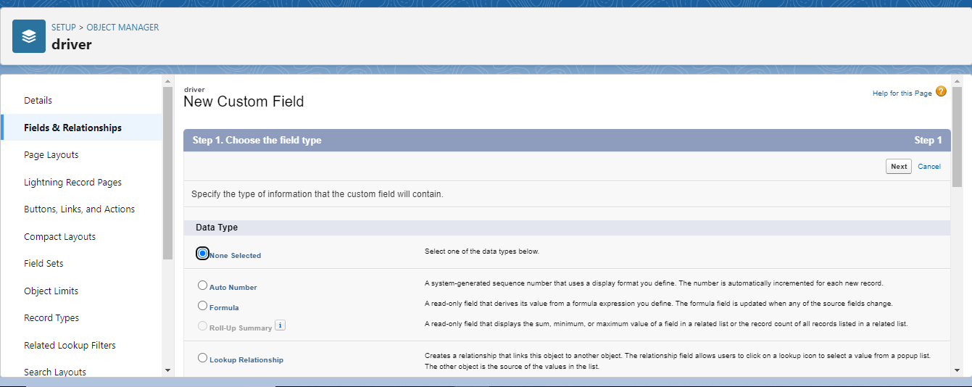

Create the Vehicle Management Construction app

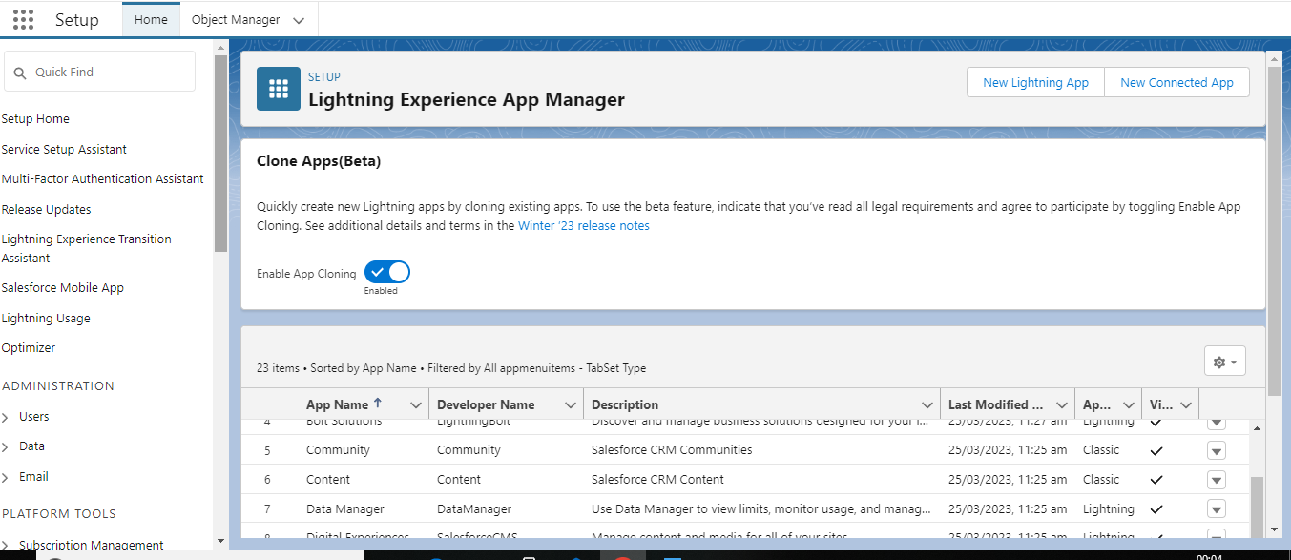

Profile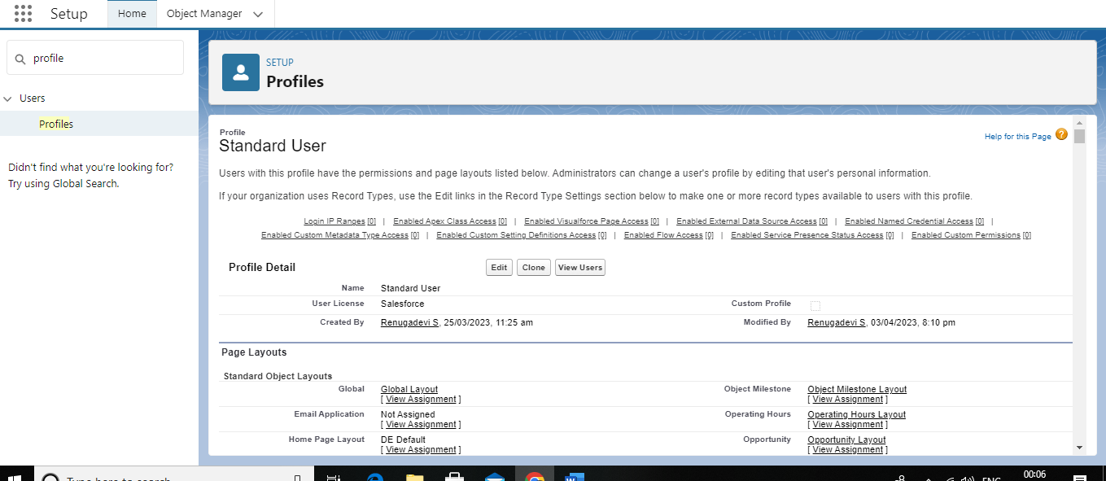

User

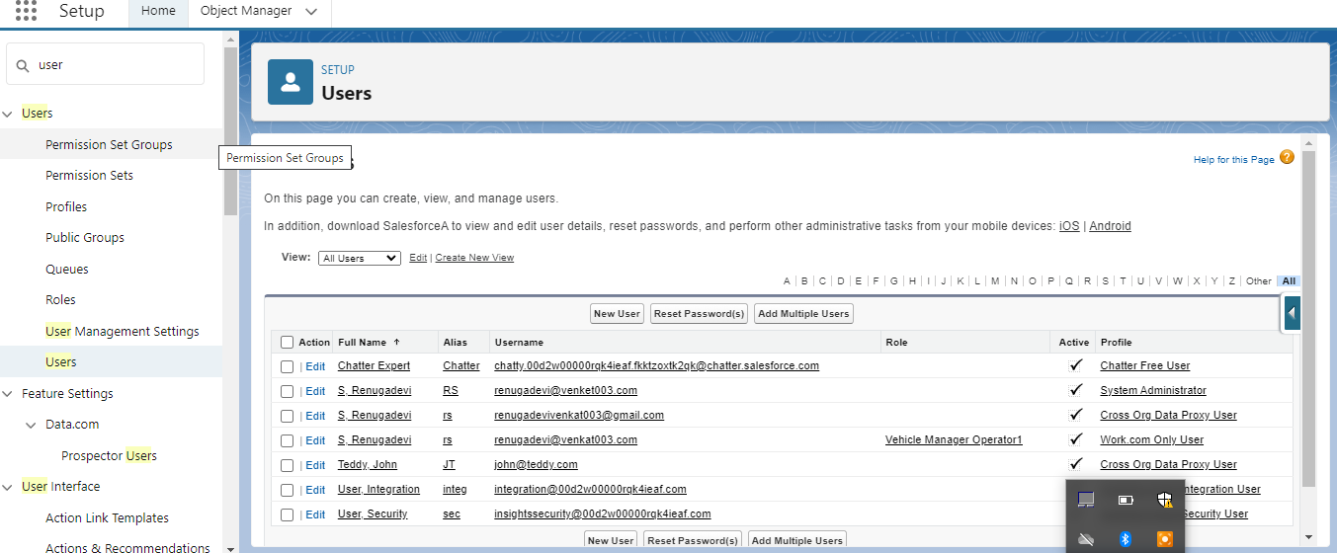

Reports

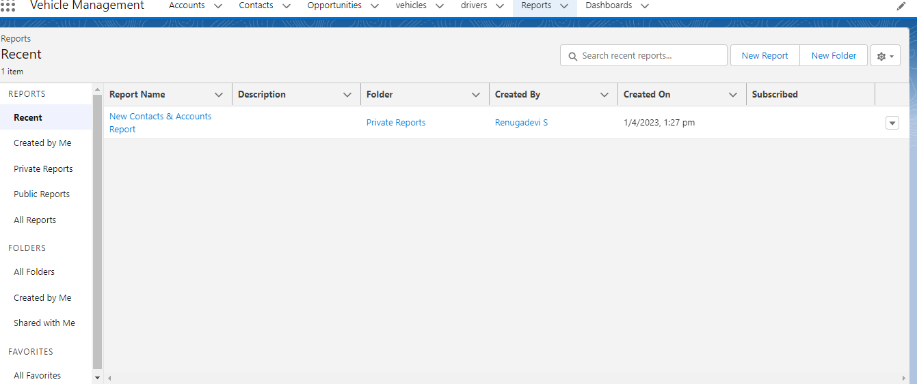

Dashboards

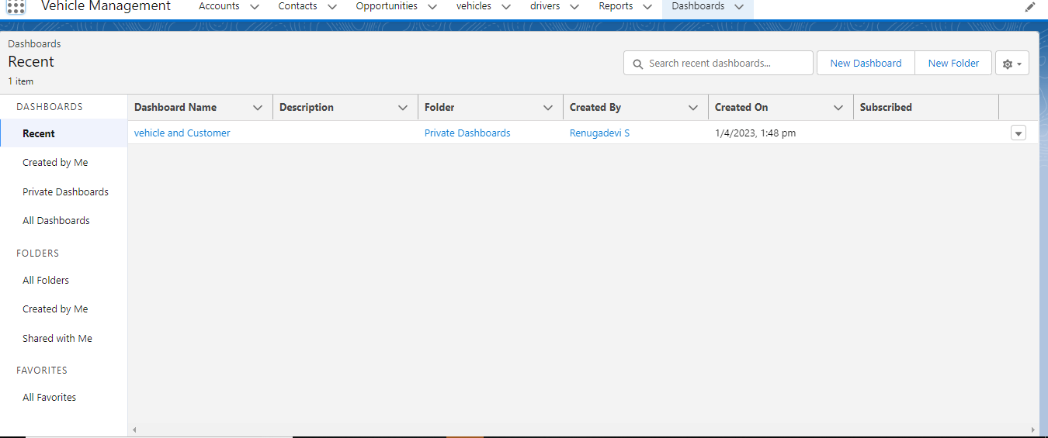

4.trailhead and profile public URL

Team lead- https://trailblazer.me/id/rsettu

Team member1- https://trailblazer.me/id/rdevi225

Team member2-https://trailblazer.me/id/rasri47

Team member3-https://trailblazer.me/id/rbanu37

5.Advantages

Depending on the type of fleet being managed, a vehicle management system can reap a few or more business benefits. Notwithstanding that it largely depends on the quality of management conducted by the fleet owner, fleet manager or fleet operator, even mere few of these benefits can make a real difference in the fleet’s performance efficiency, with substantial impact on ROI. That is to say, it may make the difference between a fleet of assets and a fleet of liabilities.

**1. The entire fleet on a single screen, in real time**

Even though a vehicle management system is typically [different from a GPS tracking system](https://www.veturilo.io/is-veturilo-a-gps-tracker/), it provides vehicle tracking capabilities. That is to say, the inability of a fleet operator to know the location and status of their fleet and drivers can give way to a variety of different problems. Granted that, poor productivity, fleet inefficiency and delayed deliveries and shipments are only a few of them. Surely, these issues, given the right circumstances, can seriously hurt business reputation and customer retention.

A vehicle management system offers full fleet visibility on a single screen. Fleet managers get all sorts of information, such as:

* Location and status of vehicles and drivers
* Trip logs and events, routes followed, delays caused
* Productivity, efficiency and performance levels of vehicles and staff
* Timely notifications regarding malfunctions and delays

In general, fleet managers and operators enjoy better insights that lead to better customer service.

Even the slightest problem in a vehicle’s engine may eventually lead to severe damage and breakdowns. To a fleet manager, there is nothing like being notified about any issue, any indication of malfunction and any sign that a driver forgot to check oil and fuel levels, lights and indicators and tire pressure before they left the lot. Even more so when there is a malfunction that just happened, brewing into some serious breakdown. In brief, all this information will be readily available to the fleet manager, per vehicle. A historical report of all incidents throughout a season will indicate whether a vehicle is due to be replaced, improving overall fleet performance.

**3. Driver and vehicle safety and reliability**

**Driver safety**

Statistically speaking, a motor vehicle crash happens approximately every 5 seconds. Peak hours in a busy rural area won’t make things easier. Fleet managers need to know how to educate drivers on [safe driving practices](https://www.veturilo.io/blog/fleet-safety-state-certified-defensive-driving-programs/). And having a driving behavior report, or a driver scorecard helps [identify the behaviors](https://www.veturilo.io/blog/4-ways-a-driver-monitoring-system-helps-your-fleet/) that need to be addressed. In many countries, it is the law that all vehicles are also equipped with an on-board camera that will record all types of incidents for future reference.

**Vehicle safety and reliability**

Additionally, a fleet of well-maintained vehicles has proven to play a very important role in safe driving, improving overall fleet safety and reliability. And, it’s only logical that poorly maintained vehicles can endanger drivers, passengers and bystanders on the road. Rightly so, alerts and notifications on any possible malfunction, non-compliance with regulations or reminders to stay ahead of normal wear and tear are uniquely useful to a fleet manager; at least, one that aims to keep the fleet well maintained and the staff well informed and professional.

**4. Improved fuel efficiency, minimized fuel fraud**

**Fuel efficiency**

Economies change and the prices of repairs, routine maintenance or even fuel, can change in an instant. In truth, fuel price is not the only factor to affect fuel efficiency. To explain, fuel consumption is the most usual culprit in cases of inefficiency. And, since fuel expenses are nearly 20% of the operating costs for a fleet, managing fuel consumption will serve its purpose.

Reducing speeding and aggressive driving behaviors will definitely reduce fuel consumption. Additionally, eliminating idling and taking more efficient routes will also help. But, properly maintaining fleet vehicles will make the most difference in the long run. Keeping air, fuel and oil filters clean, keeping the [tires](https://www.veturilo.io/blog/before-replacing-vehicle-tires/) in good condition and nominally inflated and the braking system well maintained will make all the difference in fuel efficiency — not to mention safety.

To that end, a vehicle management system provides trip information such as fast

Disadvantages

If you are talking about vehicle tracking in supply chain industry, i would say that GPS cannot measure temperature, humidity and tampering or spoilage risks and this is the major disadvantage of GPS.

If you are using beacons in that case it would be beneficial in terms of tracking your vehicle at individual package level.

**APPLICATION:**

### 1. The entire fleet on a single screen, in real time

Even though a vehicle management system is typically [different from a GPS tracking system](https://www.veturilo.io/is-veturilo-a-gps-tracker/), it provides vehicle tracking capabilities. That is to say, the inability of a fleet operator to know the location and status of their fleet and drivers can give way to a variety of different problems. Granted that, poor productivity, fleet inefficiency and delayed deliveries and shipments are only a few of them. Surely, these issues, given the right circumstances, can seriously hurt business reputation and customer retention.

A vehicle management system offers full fleet visibility on a single screen. Fleet managers get all sorts of information, such as:

* Location and status of vehicles and drivers
* Trip logs and events, routes followed, delays caused
* Productivity, efficiency and performance levels of vehicles and staff
* Timely notifications regarding malfunctions and delays

In general, fleet managers and operators enjoy better insights that lead to better customer service.

### 2. Vehicle status, readily available

Even the slightest problem in a vehicle’s engine may eventually lead to severe damage and breakdowns. To a fleet manager, there is nothing like being notified about any issue, any indication of malfunction and any sign that a driver forgot to check oil and fuel levels, lights and indicators and tire pressure before they left the lot. Even more so when there is a malfunction that just happened, brewing into some serious breakdown. In brief, all this information will be readily available to the fleet manager, per vehicle. A historical report of all incidents throughout a season will indicate whether a vehicle is due to be replaced, improving overall fleet performance.

### 3. Driver and vehicle safety and reliability

#### Driver safety

Statistically speaking, a motor vehicle crash happens approximately every 5 seconds. Peak hours in a busy rural area won’t make things easier. Fleet managers need to know how to educate drivers on [safe driving practices](https://www.veturilo.io/blog/fleet-safety-state-certified-defensive-driving-programs/). And having a driving behavior report, or a driver scorecard helps [identify the behaviors](https://www.veturilo.io/blog/4-ways-a-driver-monitoring-system-helps-your-fleet/) that need to be addressed. In many countries, it is the law that all vehicles are also equipped with an on-board camera that will record all types of incidents for future reference.

#### Vehicle safety and reliability

Additionally, a fleet of well-maintained vehicles has proven to play a very important role in safe driving, improving overall fleet safety and reliability. And, it’s only logical that poorly maintained vehicles can endanger drivers, passengers and bystanders on the road. Rightly so, alerts and notifications on any possible malfunction, non-compliance with regulations or reminders to stay ahead of normal wear and tear are uniquely useful to a fleet manager; at least, one that aims to keep the fleet well maintained and the staff well informed and professional.

### 4. Improved fuel efficiency, minimized fuel fraud

#### Fuel efficiency

Economies change and the prices of repairs, routine maintenance or even fuel, can change in an instant. In truth, fuel price is not the only factor to affect fuel efficiency. To explain, fuel consumption is the most usual culprit in cases of inefficiency. And, since fuel expenses are nearly 20% of the operating costs for a fleet, managing fuel consumption will serve its purpose.

Reducing speeding and aggressive driving behaviors will definitely reduce fuel consumption. Additionally, eliminating idling and taking more efficient routes will also help. But, properly maintaining fleet vehicles will make the most difference in the long run. Keeping air, fuel and oil filters clean, keeping the [tires](https://www.veturilo.io/blog/before-replacing-vehicle-tires/) in good condition and nominally inflated and the braking system well maintained will make all the difference in fuel efficiency — not to mention safety.

To that end, a vehicle management system provides trip information such as fast acceleration, hard turning, harsh braking, speeding and idling. Therefore, this type of information helps identify what needs to be addressed and how, on two different levels; driving behavior and vehicle maintenance.

#### No more fuel fraud

At some point, a fleet manager will be faced with a situation where, sometimes, drivers will be charging fuel and using it for their own benefit; [fuel fraud](https://www.veturilo.io/blog/fuel-fraud-in-fleet-management/). Sadly, it’s a quite common practice across industries. Especially since automated fuel dispensers have become available. It becomes worse when drivers use fuel cards.

Functionality like mileage reports and fuel consumption management help deduce the amount of fuel that should be used, as opposed to what was purchased. That alone, should be enough to help reduce or minimize the amount of fuel fraud happening in the fleet.

### 5. Improved lifespan for vehicles and equipment

Increased fuel consumption and bad mileage are dead giveaways for a low-performing vehicle; frequent malfunctions is another. Specifically, what all these things have in common is that they clearly indicate a poorly maintained vehicle. In a fleet, where a vehicle should be an asset, this is a cause for all sorts of trouble. And it can, in fact, range from damages and losses, to unsatisfied customers.

**CONCLUSION**

Integrating database technologies in vehicle management systems is considered controversial by many. The general conception of database systems is that they are highly resource demanding both with respect to memory consumption and computational overhead. Furthermore, database systems are considered too non-deterministic to be used in vehicle management systems. This is true for many general purpose database management systems. However, commercially embedded solutions exist today, with database engines as small as a few kilobytes. Furthermore, many years of research in real-time database management systems shows that these systems can be made deterministic.

FUTURE SCOPE:-

The global fleet management market size was valued at USD 24.8 billion in 2022 and is expected to grow at a CAGR of 15.6% during the forecast period 2023 to 2029. Fleet management refers to the process of managing and maintaining a company's fleet of vehicles, which can include cars, trucks, vans, buses, and other types of vehicles. Fleet management involves various tasks, such as tracking the vehicles' locations, monitoring their fuel consumption and maintenance needs, optimizing routes for efficiency, managing drivers, and ensuring compliance with regulations. Effective fleet management can help companies reduce costs, improve safety, increase productivity, and enhance customer service. Fleet management systems often use technology such as GPS tracking and telematics to collect data on vehicle and driver performance, which can be analyzed to identify areas for improvement and make informed decisions about operations and investments.